Rising Housing Prices - Full Answer
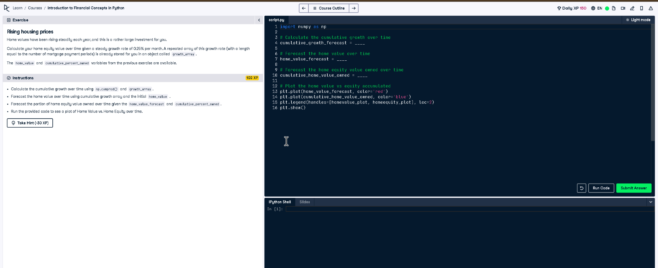

Full Code Answer:
import numpy as np
# Calculate the cumulative growth over time
cumulative_growth_forecast = np.cumprod(1 + growth_array)
# Forecast the home value over time
home_value_forecast = home_value * cumulative_growth_forecast
# Forecast the home equity value owned over time
cumulative_home_value_owned = home_value_forecast * cumulative_percent_owned
# Plot the home value vs equity accumulated
plt.plot(home_value_forecast, color='red')
plt.plot(cumulative_home_value_owned, color='blue')
plt.legend(handles=[homevalue_plot, homeequity_plot], loc=2)
plt.show()

Question:
How do we calculate rising home values and home equity growth over time considering a steady growth rate?

20-word Explanation (Question):
Home values increase steadily due to growth rates, requiring cumulative calculations to forecast future value and corresponding home equity.

Answer:
We use np.cumprod() for cumulative growth, multiply by initial home value, and apply ownership percentage to find equity.

20-word Explanation (Answer):
Using cumulative growth with np.cumprod, we forecast future home value and multiply by ownership fraction to get equity trends.

